Оглавление

Этап 1) Постановка задачи 2

Этап 2) Концепции и анализ предметной области 6

Этап 3) Объектная модель 8

Этап 4) Реализация модели на языке Smalltalk 14

Список литературы 43

# Этап 1) Постановка задачи

**Учебно-методический комплекс (УМК)** дисциплины — стандартное название для совокупности учебно-методической документации, средств обучения и контроля, разрабатываемых в высшей школе Российской Федерации для каждой дисциплины. УМК должен включать полную информацию, достаточную для прохождения дисциплины.

УМК по отдельным дисциплинам составляют основную образовательную программу (ООП) специальности (направления подготовки).

Структура УМКД в высших учебных заведениях составляется по стандарту, написанному и утверждённому в данном заведении.

УМКД содержит:

* Титульный лист
* Аннотацию
* Рабочую программу дисциплины
* Методические указания для преподавателей
* Методические указания для студентов
* Лист изменения УМК
* Приложения

*Титульный лист УМКД*

Титульный лист содержит:

* Полное и краткое название Университета
* Индекс и наименование дисциплины в соответствии с ФГОС и учебным планом
* Индекс и наименование направления подготовки в соответствии с Перечнем направлений подготовки и специальностей высшего профессионального образования.
* Полное и краткое наименование факультета
* Форма обучения
* Полное и краткое название кафедры, составившей УМКД и реализующей дисциплину
* Выписку из учебного плана по направлению

*Аннотация*

Аннотация содержит:

* Индекс и наименование дисциплины
* Индекс и наименование направления подготовки или специальности
* Название документов, на основе которых разработан УМКД (уч. План и ФГОС)
* Содержание УМКД с кратким описанием разделов:
* Описание нагрузки преподавателя м студентов (в часах)
* Цели изучения дисциплины
* Задачи изучения дисциплины
* Навыки, необходимые для успешного освоения дисциплины

*Рабочая программа дисциплины*

Рабочая программа содержит:

* Титульный лист
  + Полное и краткое название Университета
  + Индекс и наименование дисциплины
  + Индекс и наименование направления подготовки или специальности
  + Квалификация (степень) выпускника
  + Форма обучения
* Цели и задачи изучения дисциплины
* Место дисциплины в структуре ООП бакалавриата
* Компетенции обучающегося, формируемые в результате освоения дисциплины (модуля)
* Содержание дисциплины
  + Общая трудоёмкость дисциплины (в часах)
  + Наименование и содержание разделов дисциплины (модуля)
  + Разделы дисциплины (модуля), виды учебной работы и аттестации
  + Лабораторные работы (темы)
* Образовательные технологии
* Учебно – методическое обеспечение самостоятельной работы обучающихся. Оценочные средства текущего контроля успеваемости, промежуточной аттестации по итогам освоения дисциплины
  + Порядок оформления отчетов к лабораторным работам
  + Вопросы к коллоквиуму
  + Тематика курсовых работ (проектов)
* Учебно – методические материалы по дисциплине
  + Основная литература
  + Дополнительная литература
* Материально – техническое обеспечение учебного процесса

*Методические указания по дисциплине для преподавателей*

Методические материалы по дисциплине для преподавателя содержат:

* Индекс и наименование дисциплины
* Индекс и наименование направления подготовки (специальности)
* Методические рекомендации по чтению лекций
* Методические рекомендации по проведению лабораторных работ
* Методические рекомендации по руководству курсовым проектом (или курсовой работой)
* Билеты к экзамену
* Вопросы к зачету

*Методические указания по дисциплине для студентов*

Методические материалы по дисциплине для студентов содержат:

* Индекс и наименование дисциплины
* Индекс и наименование направления подготовки (специальности)
* Методические рекомендации по подготовке к лекциям
* Методические рекомендации по выполнению лабораторных работ
* Методические рекомендации по выполнению курсового проекта (или курсовой работы)

*Лист изменения УМК*

Лист изменения УМК содержит:

* Индекс и наименование дисциплины
* Таблицу, содержащую
  + Дату внесения изменений
  + Номер пункта рабочей программы УМКД, в который внесены изменения
  + Содержание изменений

# Этап 2) Концепции и анализ предметной области

1. Множество D – множество понятий, отражающих различные действия объектов предметной области (разные решения, принимаемые в данной области)
2. Множество Q – множество понятий, образующих объекты предметной области. Туда входят и абстрактные и конкретные понятия.
3. Множество P – множество понятий, отражающих свойства, признаки или различные состояния объектов предметной области.
4. Множество R – множество понятий, отражающих отношения между объектами предметной области.
5. Множество V – множество понятий, соответствующих значениям свойств и отношений.

Q = {Преподаватель, УМКД, титульный лист УМКД, аннотацию, рабочую программу дисциплины, методические указания для преподавателей, методические указания для студентов, лист изменения УМК, приложения, выписка из учебного плана, компетенции, ФГОС}

D(преподаватель) =

{

подготовить(УМКД)

запросить(выписка из учебного плана)

заполнить (титульный лист)

написать (аннотация)

определить(цели)

определить(задачи)

написать (рабочая программа)

выбрать (компетенции)

придумать (лабораторные работы)

придумать (вопросы к коллоквиуму)

придумать (темы курсовых)

составить (список литературы)

написать (методические указания для преподавателей)

написать (методические указания по дисциплине для студентов)

придумать (вопросы к зачету)

придумать (билеты к экзамену)

}

P(преподаватель) = {Работает}

P(УМКД) = {Готов}

P(Титульный лист) = {заполнен}

P(Аннотация) = {Написана}

P(Рабочая программа) = {Написана}

P(Методические указания для преподавателей) = {Написаны}

P(Методические указания для студентов) = {Написаны}

P(выписка из учебного плана) = {Получена}

P(цели изучения дисциплины) = {Определены}

P(задачи изучения дисциплины) = {Определены}

P(компетенции) = {Выбраны}

P(лабораторные работы) = {Придуманы}

P(вопросы к коллоквиуму) = {Придуманы}

P(вопросы к зачету) = {Придуманы}

P(темы курсовых) = {Придуманы}

P(билеты к экзамену) = {Придуманы}

P(список литературы) = {Составлен}

R(Титульный лист) = {в составе (УМКД)}

R(Аннотация) = { в составе (УМКД)}

R(Рабочая программа) = { в составе (УМКД)}

R(Методические указания для преподавателей) = { в составе (УМКД)}

R(Методические указания для студентов) = { в составе (УМКД)}

R(выписка из учебного плана) = {есть у (Преподаватель)}

R(цели изучения дисциплины) = {в составе (рабочая программа)}

R(задачи изучения дисциплины) = {в составе (рабочая программа)}

R(компетенции) = { в составе (рабочая программа)}

R(лабораторные работы) = { в составе (рабочая программа)}

R(вопросы к коллоквиуму) = { в составе (рабочая программа)}

R(вопросы к зачету) = { в составе (Методические указания для преподавателей)}

R(темы курсовых) = { в составе (рабочая программа)}

R(билеты к экзамену) = { в составе (Методические указания для преподавателей)}

R(список литературы) = { в составе (рабочая программа)}

# Этап 3) Объектная модель

Для реализации модели были выбраны следующие классы:

|  |  |
| --- | --- |
| Преподаватель | |
| Работает  УМКД  Выписка из учебного плана | Подготовить УМКД  Запросить выписку из учебного плана  Заполнить титульный лист  Написать аннотацию  Определить цели  Определить задачи  Написать рабочую программу  Выбрать компетенции  Придумать лабораторные работы  Придумать вопросы к коллоквиуму  Придумать темы курсовых  Составить список литературы  Написать методические указания для преподавателей  Написать методические указания по дисциплине для студентов  Придумать вопросы к зачету  Придумать билеты к экзамену |
|  |

|  |  |
| --- | --- |
| УМКД | |
| Готов |  |
| Титульный лист  Аннотация  Рабочая программа  Методические указания для преподавателей  Методические указания для студентов |

|  |  |
| --- | --- |
| Методические указания для преподавателей | |
| Готовы  Вопросы к зачету  Билеты к экзамену |  |
| В составе УМКД |

|  |  |
| --- | --- |
| Рабочая программа | |
| Готова  Цели изучения дисциплины  Задачи изучения дисциплины  Компетенции  Лабораторные работы  Вопросы к коллоквиуму  Темы курсовых  Список литературы |  |
| В составе УМКД |

*Концептуальные структуры действия:*















# Этап 4) Реализация модели на языке Smalltalk

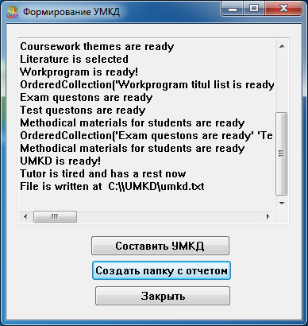

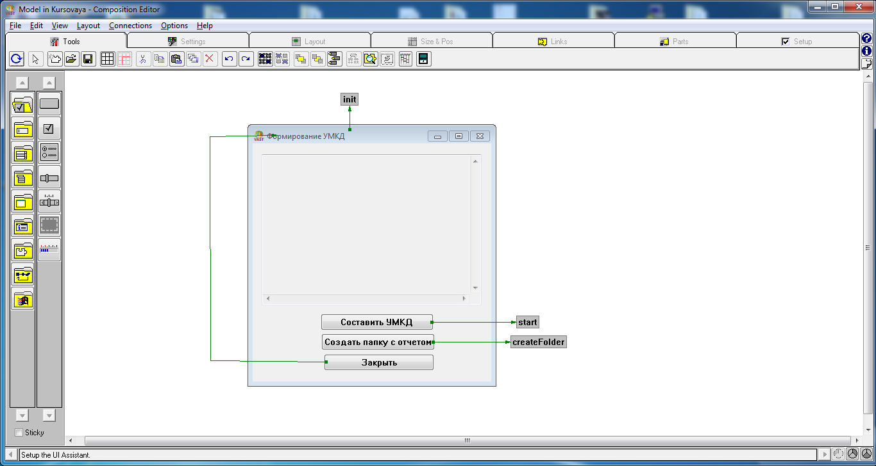

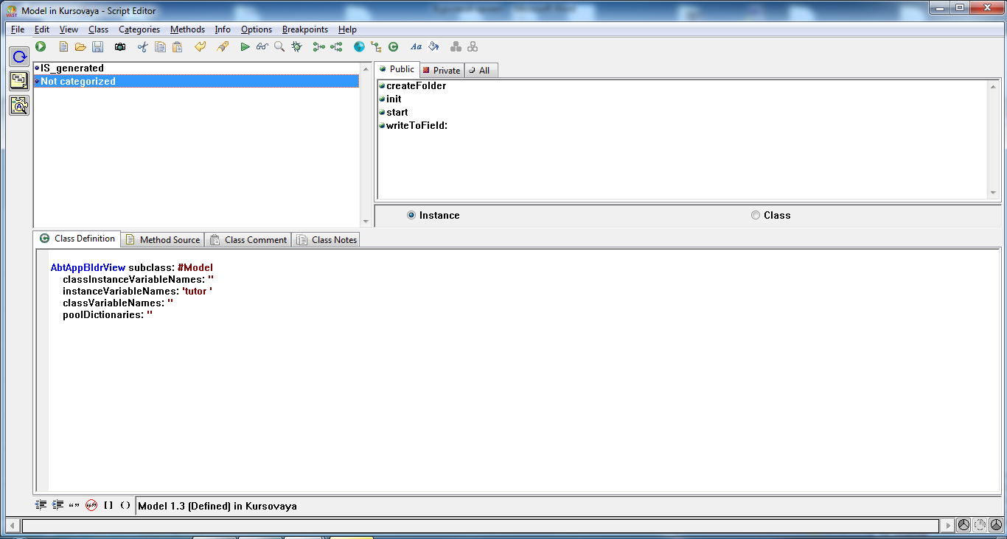

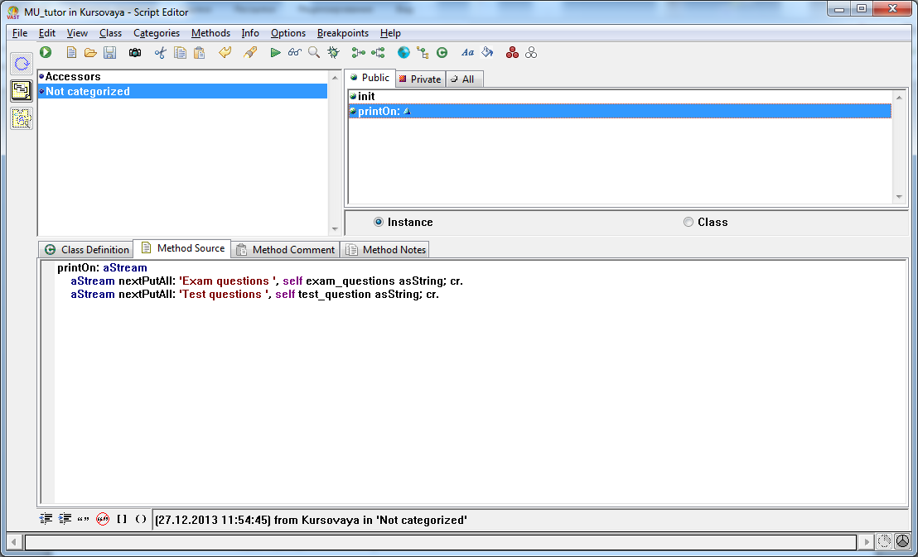

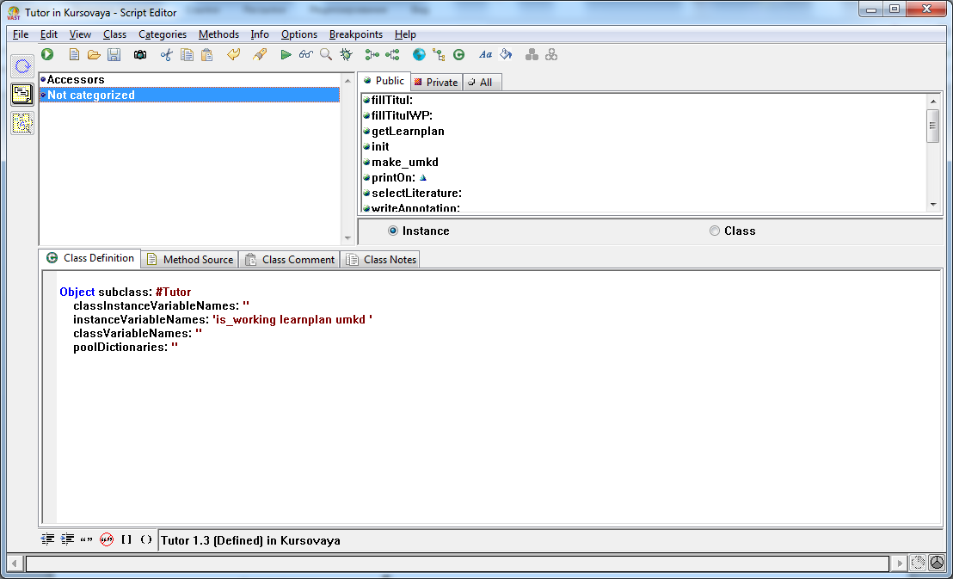

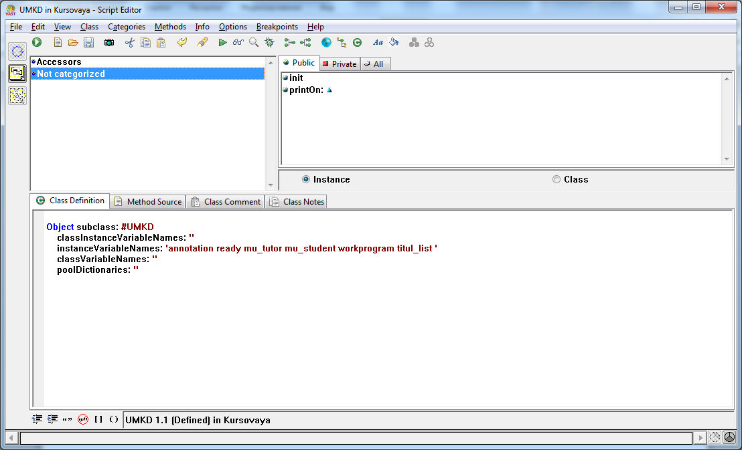

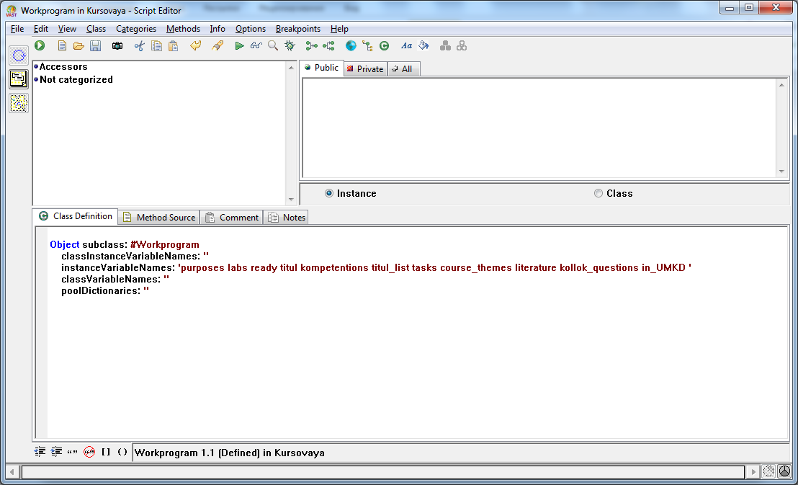

**Код программы:**

"$COMPATIBLE-DECLARATIONS-START$"

Smalltalk declarePoolDictionary: 'IS_Model'.

Smalltalk declareVariable: 'IS_instanceInterfaceSpec' poolName: 'IS_Model'.

Smalltalk declarePoolDictionary: 'IS_MU_tutor'.

Smalltalk declareVariable: 'IS_ready' poolName: 'IS_MU_tutor'.

Smalltalk declareVariable: 'IS_exam_questions' poolName: 'IS_MU_tutor'.

Smalltalk declareVariable: 'IS_test_questions' poolName: 'IS_MU_tutor'.

Smalltalk declareVariable: 'IS_init' poolName: 'IS_MU_tutor'.

Smalltalk declareVariable: 'IS_instanceInterfaceSpec' poolName: 'IS_MU_tutor'.

Smalltalk declarePoolDictionary: 'IS_Tutor'.

Smalltalk declareVariable: 'IS_set' poolName: 'IS_Tutor'.

Smalltalk declareVariable: 'IS_is_working' poolName: 'IS_Tutor'.

Smalltalk declareVariable: 'IS_init' poolName: 'IS_Tutor'.

Smalltalk declareVariable: 'IS_fill' poolName: 'IS_Tutor'.

Smalltalk declareVariable: 'IS_umkd' poolName: 'IS_Tutor'.

Smalltalk declareVariable: 'IS_write' poolName: 'IS_Tutor'.

Smalltalk declareVariable: 'IS_learnplan' poolName: 'IS_Tutor'.

Smalltalk declareVariable: 'IS_get' poolName: 'IS_Tutor'.

Smalltalk declareVariable: 'IS_make' poolName: 'IS_Tutor'.

Smalltalk declareVariable: 'IS_select' poolName: 'IS_Tutor'.

Smalltalk declareVariable: 'IS_instanceInterfaceSpec' poolName: 'IS_Tutor'.

Smalltalk declarePoolDictionary: 'IS_UMKD'.

Smalltalk declareVariable: 'IS_ready' poolName: 'IS_UMKD'.

Smalltalk declareVariable: 'IS_titul_list' poolName: 'IS_UMKD'.

Smalltalk declareVariable: 'IS_mu_student' poolName: 'IS_UMKD'.

Smalltalk declareVariable: 'IS_init' poolName: 'IS_UMKD'.

Smalltalk declareVariable: 'IS_annotation' poolName: 'IS_UMKD'.

Smalltalk declareVariable: 'IS_mu_tutor' poolName: 'IS_UMKD'.

Smalltalk declareVariable: 'IS_workprogram' poolName: 'IS_UMKD'.

Smalltalk declareVariable: 'IS_instanceInterfaceSpec' poolName: 'IS_UMKD'.

Smalltalk declarePoolDictionary: 'IS_Workprogram'.

Smalltalk declareVariable: 'IS_ready' poolName: 'IS_Workprogram'.

Smalltalk declareVariable: 'IS_kollok_questions' poolName: 'IS_Workprogram'.

Smalltalk declareVariable: 'IS_labs' poolName: 'IS_Workprogram'.

Smalltalk declareVariable: 'IS_course_themes' poolName: 'IS_Workprogram'.

Smalltalk declareVariable: 'IS_titul_list' poolName: 'IS_Workprogram'.

Smalltalk declareVariable: 'IS_init' poolName: 'IS_Workprogram'.

Smalltalk declareVariable: 'IS_tasks' poolName: 'IS_Workprogram'.

Smalltalk declareVariable: 'IS_purposes' poolName: 'IS_Workprogram'.

Smalltalk declareVariable: 'IS_kompetentions' poolName: 'IS_Workprogram'.

Smalltalk declareVariable: 'IS_literature' poolName: 'IS_Workprogram'.

Smalltalk declareVariable: 'IS_instanceInterfaceSpec' poolName: 'IS_Workprogram'.

"$COMPATIBLE-DECLARATIONS-END$"!

Application create: #Kursovaya with:

(#( AbtViewApplication)

collect: [:each | Smalltalk at: each ifAbsent: [

Application errorPrerequisite: #Kursovaya missing: each]])!

Kursovaya becomeDefault!

AbtAppBldrView subclass: #Model

classInstanceVariableNames: ''

instanceVariableNames: 'tutor '

classVariableNames: ''

poolDictionaries: ''!

Kursovaya becomeDefault!

Object subclass: #MU_tutor

classInstanceVariableNames: ''

instanceVariableNames: 'ready exam_questions in_UMKD test_questions '

classVariableNames: ''

poolDictionaries: ''!

Kursovaya becomeDefault!

Application subclass: #Kursovaya

classInstanceVariableNames: ''

instanceVariableNames: ''

classVariableNames: ''

poolDictionaries: ''!

Kursovaya becomeDefault!

Object subclass: #Tutor

classInstanceVariableNames: ''

instanceVariableNames: 'is_working learnplan umkd '

classVariableNames: ''

poolDictionaries: ''!

Kursovaya becomeDefault!

Object subclass: #UMKD

classInstanceVariableNames: ''

instanceVariableNames: 'annotation ready mu_tutor mu_student workprogram titul_list '

classVariableNames: ''

poolDictionaries: ''!

Kursovaya becomeDefault!

Object subclass: #Workprogram

classInstanceVariableNames: ''

instanceVariableNames: 'purposes labs ready titul kompetentions titul_list tasks course_themes literature kollok_questions in_UMKD '

classVariableNames: ''

poolDictionaries: ''!

Kursovaya becomeDefault!

!Kursovaya class privateMethods !

abtIsViewApplication

^true! !

!Model class privateMethods !

_PRAGMA_IS_

"%%PRAGMA DECLARE

(name: IS_Model isPool: true isConstant: false)

(pool: IS_Model declarations: (

(name: IS_instanceInterfaceSpec isConstant: false)

))"!

abtPrimFlushInterfaceSpecCache

IS_Model associationsDo: [: poolDictionaryAssoc | poolDictionaryAssoc value: nil].

super abtPrimFlushInterfaceSpecCache!

abtUntranslatedConstants

"** Do not modify or delete ** See: AbtAppBldrPart class>>#about_abtUntranslatedConstants"

^#(

'Формирование УМКД'

'Закрыть'

'Создать папку с отчетом'

'Составить УМКД'

)!

IS_instanceInterfaceSpec

"Private - ** Warning ** This method is generated by VisualAge and should not

be modified or deleted. This method is responsible for returning a featureSpec

that describes the implementation of a particular feature of the receiver"

^IS_Model::IS_instanceInterfaceSpec notNil

ifTrue: [IS_Model::IS_instanceInterfaceSpec]

ifFalse: [

IS_Model::IS_instanceInterfaceSpec := AbtInterfaceSpec new]! !

!Model publicMethods !

createFolder

|file|

CfsDirectoryDescriptor mkdir: 'C:\\UMKD'.

CfsDirectoryDescriptor chdir: 'C:\\UMKD'.

file := CfsReadWriteFileStream openEmpty: 'umkd.txt'.

tutor printOn: file.

file close.

self writeToField: 'File is written at C:\\UMKD\umkd.txt'.

!

init

"initialization"

tutor := Tutor new.

tutor init.

!

start

tutor is_working = true ifTrue: [

self writeToField: (tutor make_umkd).

tutor is_working: false.

] ifFalse: [self writeToField: ('Tutor is tired and has a rest now').]

!

writeToField: str

"write"

|printFunc|

printFunc := [:st | (self subpartNamed: 'mainEditor') insertText: (st asString, CwText lineDelimiter) position: (self subpartNamed: 'mainEditor') cursorPosition].

str class = False ifTrue: [ ^false ].

str class = OrderedCollection ifTrue: [

str do: [ :val |

val class = OrderedCollection ifTrue: [self writeToField: val.].

printFunc value: (val asString)

]

] ifFalse: [

printFunc value: str.

].

! !

!Model privateMethods !

abtBuildInternals

"** Do not modify or delete ** See: AbtAppBldrPart class>>#about_abtBuildInternals"

| gui window mainEditor pushButton1 pushButton2 pushButton3 conn0 conn1 conn2 conn3 |

gui := self class abtSeparatedConstants.

window := AbtShellView abtCreatePart: 'Window' parent: nil owner: self .

mainEditor := AbtMultiLineEditView abtCreatePart: 'mainEditor' parent: window.

pushButton1 := AbtPushButtonView abtCreatePart: 'Push Button1' parent: window.

pushButton2 := AbtPushButtonView abtCreatePart: 'Push Button2' parent: window.

pushButton3 := AbtPushButtonView abtCreatePart: 'Push Button3' parent: window.

self

primaryPart: window.

window

framingSpec: (AbtViewAttachmentConstraint new

leftEdge: (AbtEdgeConstant new offset: 296);

rightEdge: (AbtEdgeConstant new offset: 372);

topEdge: (AbtEdgeConstant new offset: 84);

bottomEdge: (AbtEdgeConstant new offset: 372));

title: (gui at: 1) " 'Формирование УМКД' " .

mainEditor

framingSpec: (AbtViewAttachmentConstraint new

leftEdge: (AbtRunEdgeAttachmentConstraint new attachment: XmATTACHFORM; offset: 14);

rightEdge: (AbtRunEdgeAttachmentConstraint new attachment: XmATTACHSELFOPPOSITE; offset: 343);

topEdge: (AbtRunEdgeAttachmentConstraint new attachment: XmATTACHFORM; offset: 17);

bottomEdge: (AbtRunEdgeAttachmentConstraint new attachment: XmATTACHSELFOPPOSITE; offset: 236));

editable: false.

pushButton1

object: (gui at: 2) " 'Закрыть' " ;

framingSpec: (AbtViewAttachmentConstraint new

leftEdge: (AbtRunEdgeAttachmentConstraint new attachment: XmATTACHFORM; offset: 111);

rightEdge: (AbtRunEdgeAttachmentConstraint new attachment: XmATTACHSELFOPPOSITE; offset: 172);

topEdge: (AbtRunEdgeAttachmentConstraint new attachment: XmATTACHFORM; offset: 329);

bottomEdge: (AbtRunEdgeAttachmentConstraint new attachment: XmATTACHNONE)).

pushButton2

object: (gui at: 3) " 'Создать папку с отчетом' " ;

framingSpec: (AbtViewAttachmentConstraint new

leftEdge: (AbtRunEdgeAttachmentConstraint new attachment: XmATTACHFORM; offset: 107);

rightEdge: (AbtRunEdgeAttachmentConstraint new attachment: XmATTACHNONE);

topEdge: (AbtRunEdgeAttachmentConstraint new attachment: XmATTACHFORM; offset: 297);

bottomEdge: (AbtRunEdgeAttachmentConstraint new attachment: XmATTACHNONE)).

pushButton3

object: (gui at: 4) " 'Составить УМКД' " ;

framingSpec: (AbtViewAttachmentConstraint new

leftEdge: (AbtRunEdgeAttachmentConstraint new attachment: XmATTACHFORM; offset: 106);

rightEdge: (AbtRunEdgeAttachmentConstraint new attachment: XmATTACHSELFOPPOSITE; offset: 176);

topEdge: (AbtRunEdgeAttachmentConstraint new attachment: XmATTACHFORM; offset: 266);

bottomEdge: (AbtRunEdgeAttachmentConstraint new attachment: XmATTACHNONE)).

pushButton1

abtWhenPrimitive: #clicked

perform:

(DirectedMessage new

receiver: window;

selector: #closeWidgetCommand;

arguments: #()).

window

abtWhenPrimitive: #openedWidget

perform:

(DirectedMessage new

receiver: self;

selector: #init;

arguments: #()).

pushButton3

abtWhenPrimitive: #clicked

perform:

(DirectedMessage new

receiver: self;

selector: #start;

arguments: #()).

pushButton2

abtWhenPrimitive: #clicked

perform:

(DirectedMessage new

receiver: self;

selector: #createFolder;

arguments: #()).

self finalInitialize.

! !

!MU_tutor class privateMethods !

_PRAGMA_IS_

"%%PRAGMA DECLARE

(name: IS_MU_tutor isPool: true isConstant: false)

(pool: IS_MU_tutor declarations: (

(name: IS_ready isConstant: false)

(name: IS_exam_questions isConstant: false)

(name: IS_test_questions isConstant: false)

(name: IS_init isConstant: false)

(name: IS_instanceInterfaceSpec isConstant: false)

))"!

abtPrimFlushInterfaceSpecCache

IS_MU_tutor associationsDo: [: poolDictionaryAssoc | poolDictionaryAssoc value: nil].

super abtPrimFlushInterfaceSpecCache!

IS_exam_questions

"Private - ** Warning ** This method is generated by VisualAge and should not

be modified or deleted. This method is responsible for returning a featureSpec

that describes the implementation of a particular feature of the receiver"

^IS_MU_tutor::IS_exam_questions notNil

ifTrue: [IS_MU_tutor::IS_exam_questions]

ifFalse: [

IS_MU_tutor::IS_exam_questions := (AbtAttributeSpec new

attributeType: Boolean;

setSelector: #exam_questions:;

getSelector: #exam_questions;

changeSymbol: #exam_questions)]!

IS_init

"Private - ** Warning ** This method is generated by VisualAge and should not

be modified or deleted. This method is responsible for returning a featureSpec

that describes the implementation of a particular feature of the receiver"

^IS_MU_tutor::IS_init notNil

ifTrue: [IS_MU_tutor::IS_init]

ifFalse: [

IS_MU_tutor::IS_init := (AbtActionSpec new

selector: #init)]!

IS_instanceInterfaceSpec

"Private - ** Warning ** This method is generated by VisualAge and should not

be modified or deleted. This method is responsible for returning a featureSpec

that describes the implementation of a particular feature of the receiver"

^IS_MU_tutor::IS_instanceInterfaceSpec notNil

ifTrue: [IS_MU_tutor::IS_instanceInterfaceSpec]

ifFalse: [

IS_MU_tutor::IS_instanceInterfaceSpec := AbtInterfaceSpec new

featureNamed: #ready put: self IS_ready;

featureNamed: #exam_questions put: self IS_exam_questions;

featureNamed: #test_questions put: self IS_test_questions;

featureNamed: #init put: self IS_init]!

IS_ready

"Private - ** Warning ** This method is generated by VisualAge and should not

be modified or deleted. This method is responsible for returning a featureSpec

that describes the implementation of a particular feature of the receiver"

^IS_MU_tutor::IS_ready notNil

ifTrue: [IS_MU_tutor::IS_ready]

ifFalse: [

IS_MU_tutor::IS_ready := (AbtAttributeSpec new

attributeType: Boolean;

setSelector: #ready:;

getSelector: #ready;

changeSymbol: #ready)]!

IS_test_questions

"Private - ** Warning ** This method is generated by VisualAge and should not

be modified or deleted. This method is responsible for returning a featureSpec

that describes the implementation of a particular feature of the receiver"

^IS_MU_tutor::IS_test_questions notNil

ifTrue: [IS_MU_tutor::IS_test_questions]

ifFalse: [

IS_MU_tutor::IS_test_questions := (AbtAttributeSpec new

attributeType: Boolean;

setSelector: #test_question:;

getSelector: #test_question;

changeSymbol: #test_question)]! !

!MU_tutor publicMethods !

exam_questions

"Return the value of exam_questions."

^exam_questions!

exam_questions: aBoolean

"Save the value of exam_questions."

exam_questions := aBoolean.

self signalEvent: #exam_questions

with: aBoolean.!

init

"Perform the init action."

self exam_questions: false.

self test_question: false.

self ready: false.!

printOn: aStream

aStream nextPutAll: 'Exam questions ', self exam_questions asString; cr.

aStream nextPutAll: 'Test questions ', self test_question asString; cr. !

ready

"Return the value of ready."

^ready!

ready: aBoolean

"Save the value of ready."

ready := aBoolean.

self signalEvent: #ready

with: aBoolean.!

test_question

"Return the value of test_questions."

^test_questions!

test_question: aBoolean

"Save the value of test_questions."

test_questions := aBoolean.

self signalEvent: #test_question

with: aBoolean.! !

!Tutor class privateMethods !

_PRAGMA_IS_

"%%PRAGMA DECLARE

(name: IS_Tutor isPool: true isConstant: false)

(pool: IS_Tutor declarations: (

(name: IS_set isConstant: false)

(name: IS_is_working isConstant: false)

(name: IS_init isConstant: false)

(name: IS_fill isConstant: false)

(name: IS_umkd isConstant: false)

(name: IS_write isConstant: false)

(name: IS_learnplan isConstant: false)

(name: IS_get isConstant: false)

(name: IS_make isConstant: false)

(name: IS_select isConstant: false)

(name: IS_instanceInterfaceSpec isConstant: false)

))"!

abtPrimFlushInterfaceSpecCache

IS_Tutor associationsDo: [: poolDictionaryAssoc | poolDictionaryAssoc value: nil].

super abtPrimFlushInterfaceSpecCache!

IS_fill

"Private - ** Warning ** This method is generated by VisualAge and should not

be modified or deleted. This method is responsible for returning a featureSpec

that describes the implementation of a particular feature of the receiver"

^IS_Tutor::IS_fill notNil

ifTrue: [IS_Tutor::IS_fill]

ifFalse: [

IS_Tutor::IS_fill := (AbtActionSpec new

selector: #fill)]!

IS_get

"Private - ** Warning ** This method is generated by VisualAge and should not

be modified or deleted. This method is responsible for returning a featureSpec

that describes the implementation of a particular feature of the receiver"

^IS_Tutor::IS_get notNil

ifTrue: [IS_Tutor::IS_get]

ifFalse: [

IS_Tutor::IS_get := (AbtActionSpec new

selector: #get)]!

IS_init

"Private - ** Warning ** This method is generated by VisualAge and should not

be modified or deleted. This method is responsible for returning a featureSpec

that describes the implementation of a particular feature of the receiver"

^IS_Tutor::IS_init notNil

ifTrue: [IS_Tutor::IS_init]

ifFalse: [

IS_Tutor::IS_init := (AbtActionSpec new

selector: #init)]!

IS_instanceInterfaceSpec

"Private - ** Warning ** This method is generated by VisualAge and should not

be modified or deleted. This method is responsible for returning a featureSpec

that describes the implementation of a particular feature of the receiver"

^IS_Tutor::IS_instanceInterfaceSpec notNil

ifTrue: [IS_Tutor::IS_instanceInterfaceSpec]

ifFalse: [

IS_Tutor::IS_instanceInterfaceSpec := AbtInterfaceSpec new

featureNamed: #set put: self IS_set;

featureNamed: #is_working put: self IS_is_working;

featureNamed: #init put: self IS_init;

featureNamed: #fill put: self IS_fill;

featureNamed: #umkd put: self IS_umkd;

featureNamed: #write put: self IS_write;

featureNamed: #learnplan put: self IS_learnplan;

featureNamed: #get put: self IS_get;

featureNamed: #make put: self IS_make;

featureNamed: #select put: self IS_select]!

IS_is_working

"Private - ** Warning ** This method is generated by VisualAge and should not

be modified or deleted. This method is responsible for returning a featureSpec

that describes the implementation of a particular feature of the receiver"

^IS_Tutor::IS_is_working notNil

ifTrue: [IS_Tutor::IS_is_working]

ifFalse: [

IS_Tutor::IS_is_working := (AbtAttributeSpec new

attributeType: Boolean;

setSelector: #is_working:;

getSelector: #is_working;

changeSymbol: #is_working)]!

IS_learnplan

"Private - ** Warning ** This method is generated by VisualAge and should not

be modified or deleted. This method is responsible for returning a featureSpec

that describes the implementation of a particular feature of the receiver"

^IS_Tutor::IS_learnplan notNil

ifTrue: [IS_Tutor::IS_learnplan]

ifFalse: [

IS_Tutor::IS_learnplan := (AbtAttributeSpec new

attributeType: Boolean;

setSelector: #learnplan:;

getSelector: #learnplan;

changeSymbol: #learnplan)]!

IS_make

"Private - ** Warning ** This method is generated by VisualAge and should not

be modified or deleted. This method is responsible for returning a featureSpec

that describes the implementation of a particular feature of the receiver"

^IS_Tutor::IS_make notNil

ifTrue: [IS_Tutor::IS_make]

ifFalse: [

IS_Tutor::IS_make := (AbtActionSpec new

selector: #make)]!

IS_select

"Private - ** Warning ** This method is generated by VisualAge and should not

be modified or deleted. This method is responsible for returning a featureSpec

that describes the implementation of a particular feature of the receiver"

^IS_Tutor::IS_select notNil

ifTrue: [IS_Tutor::IS_select]

ifFalse: [

IS_Tutor::IS_select := (AbtActionSpec new

selector: #select)]!

IS_set

"Private - ** Warning ** This method is generated by VisualAge and should not

be modified or deleted. This method is responsible for returning a featureSpec

that describes the implementation of a particular feature of the receiver"

^IS_Tutor::IS_set notNil

ifTrue: [IS_Tutor::IS_set]

ifFalse: [

IS_Tutor::IS_set := (AbtActionSpec new

selector: #set)]!

IS_umkd

"Private - ** Warning ** This method is generated by VisualAge and should not

be modified or deleted. This method is responsible for returning a featureSpec

that describes the implementation of a particular feature of the receiver"

^IS_Tutor::IS_umkd notNil

ifTrue: [IS_Tutor::IS_umkd]

ifFalse: [

IS_Tutor::IS_umkd := (AbtAttributeSpec new

attributeType: UMKD;

setSelector: #umkd:;

getSelector: #umkd;

changeSymbol: #umkd)]!

IS_write

"Private - ** Warning ** This method is generated by VisualAge and should not

be modified or deleted. This method is responsible for returning a featureSpec

that describes the implementation of a particular feature of the receiver"

^IS_Tutor::IS_write notNil

ifTrue: [IS_Tutor::IS_write]

ifFalse: [

IS_Tutor::IS_write := (AbtActionSpec new

selector: #write)]! !

!Tutor publicMethods !

fillTitul: umkd

"Perform the titul page filling action."

umkd titul_list = false ifTrue: [

umkd titul_list: true.

^'UMKD titul list is ready'

].

^false!

fillTitulWP: workprogram

"Perform the titul page filling action."

workprogram titul_list = false ifTrue: [

workprogram titul_list: true.

^'Workprogram titul list is ready'

].

^false!

getLearnplan

"Perform the getting learning plan action."

self learnplan = false ifTrue: [

self learnplan: true.

^'List from learning plan is ready'

].

^false!

init

"Perform the init action."

self is_working: true.

self learnplan: false.

self.umkd := UMKD new.

umkd init.

!

is_working

"Return the value of is_working."

^is_working!

is_working: aBoolean

"Save the value of is_working."

is_working := aBoolean.

self signalEvent: #is_working

with: aBoolean.!

learnplan

"Return the value of learnplan."

^learnplan!

learnplan: aBoolean

"Save the value of learnplan."

learnplan := aBoolean.

self signalEvent: #learnplan

with: aBoolean.!

make_umkd

"Perform the UMKD creation action."

|msg|

msg := OrderedCollection new.

self.umkd ready = false ifTrue: [

msg add: (self getLearnplan).

msg add: (self fillTitul: umkd).

msg add: (self writeAnnotation: umkd ).

msg add: (self writeWorkprogram: umkd workprogram).

msg add: (self writeMuTutor: umkd mu_tutor).

msg add: (self writeMuStudent: umkd).

umkd ready: true.

msg add: 'UMKD is ready!!'.

^msg.

].

^false !

printOn: aStream

aStream nextPutAll: 'Workprogram ', umkd ready asString; cr.

umkd printOn: aStream.

aStream cr.

!

selectLiterature: workprogram

"Perform the selection literature in workprogram write action."

workprogram literature = false ifTrue: [

workprogram literature: true.

^'Literature is selected'

].

^false!

writeAnnotation: umkd

"Perform the Annotation write action."

umkd annotation = false ifTrue: [

umkd annotation: true.

^'Annotation is ready'

].

^false!

writeCourseThemes: workprogram

"Perform the coursework themes in workprogram write action."

workprogram course_themes = false ifTrue: [

workprogram course_themes: true.

^'Coursework themes are ready'

].

^false!

writeExamQuestons: mu_tutor

"Perform the exam questons in materials for tutors write action."

mu_tutor exam_questions = false ifTrue: [

mu_tutor exam_questions: true.

^'Exam questons are ready'

].

^false!

writeKollokQuestons: workprogram

"Perform the kollokvium questons in workprogram write action."

workprogram kollok_questions = false ifTrue: [

workprogram kollok_questions: true.

^'Kollokvium questons are ready'

].

^false!

writeKompetentions: workprogram

"Perform the kompetentions in workprogram write action."

workprogram kompetentions = false ifTrue: [

workprogram kompetentions: true.

^'Kompetentions are ready'

].

^false!

writeLabs: workprogram

"Perform the labs in workprogram write action."

workprogram labs = false ifTrue: [

workprogram labs: true.

^'Labs are ready'

].

^false!

writeMuStudent: umkd

"Perform writing methodiacal materials for students action."

umkd mu_student = false ifTrue: [

umkd mu_student: true.

^'Methodical materials for students are ready'

].

^false!

writeMuTutor: mu_tutor

"Perform the write action."

|msg|

msg := OrderedCollection new.

mu_tutor ready = false ifTrue: [

msg add: (self writeExamQuestons: mu_tutor).

msg add: (self writeTestQuestons: mu_tutor ).

mu_tutor ready: true.

msg add: 'Methodical materials for students are ready'.

^msg.

].

^false !

writePurposes: workprogram

"Perform the purposes in workprogram write action."

workprogram purposes = false ifTrue: [

workprogram purposes: true.

^'Purposes are ready'

].

^false!

writeTasks: workprogram

"Perform the tasks in workprogram write action."

workprogram tasks = false ifTrue: [

workprogram tasks: true.

^'Tasks are ready'

].

^false!

writeTestQuestons: mu_tutor

"Perform the test questons in materials for tutors write action."

mu_tutor test_question = false ifTrue: [

mu_tutor test_question: true.

^'Test questons are ready'

].

^false!

writeWorkprogram: workprogram

"Perform the workprogram write action."

|msg|

msg := OrderedCollection new.

workprogram ready = false ifTrue: [

msg add: (self fillTitulWP: workprogram).

msg add: (self writeTasks: workprogram ).

msg add: (self writePurposes: workprogram ).

msg add: (self writeKompetentions: workprogram ).

msg add: (self writeLabs: workprogram ).

msg add: (self writeKollokQuestons: workprogram ).

msg add: (self writeCourseThemes: workprogram ).

msg add: (self selectLiterature: workprogram ).

workprogram ready: true.

msg add: 'Workprogram is ready!!'.

^msg.

].

^false ! !

!UMKD class privateMethods !

_PRAGMA_IS_

"%%PRAGMA DECLARE

(name: IS_UMKD isPool: true isConstant: false)

(pool: IS_UMKD declarations: (

(name: IS_ready isConstant: false)

(name: IS_titul_list isConstant: false)

(name: IS_mu_student isConstant: false)

(name: IS_init isConstant: false)

(name: IS_annotation isConstant: false)

(name: IS_mu_tutor isConstant: false)

(name: IS_workprogram isConstant: false)

(name: IS_instanceInterfaceSpec isConstant: false)

))"!

abtPrimFlushInterfaceSpecCache

IS_UMKD associationsDo: [: poolDictionaryAssoc | poolDictionaryAssoc value: nil].

super abtPrimFlushInterfaceSpecCache!

IS_annotation

"Private - ** Warning ** This method is generated by VisualAge and should not

be modified or deleted. This method is responsible for returning a featureSpec

that describes the implementation of a particular feature of the receiver"

^IS_UMKD::IS_annotation notNil

ifTrue: [IS_UMKD::IS_annotation]

ifFalse: [

IS_UMKD::IS_annotation := (AbtAttributeSpec new

attributeType: Boolean;

setSelector: #annotation:;

getSelector: #annotation;

changeSymbol: #annotation)]!

IS_init

"Private - ** Warning ** This method is generated by VisualAge and should not

be modified or deleted. This method is responsible for returning a featureSpec

that describes the implementation of a particular feature of the receiver"

^IS_UMKD::IS_init notNil

ifTrue: [IS_UMKD::IS_init]

ifFalse: [

IS_UMKD::IS_init := (AbtActionSpec new

selector: #init)]!

IS_instanceInterfaceSpec

"Private - ** Warning ** This method is generated by VisualAge and should not

be modified or deleted. This method is responsible for returning a featureSpec

that describes the implementation of a particular feature of the receiver"

^IS_UMKD::IS_instanceInterfaceSpec notNil

ifTrue: [IS_UMKD::IS_instanceInterfaceSpec]

ifFalse: [

IS_UMKD::IS_instanceInterfaceSpec := AbtInterfaceSpec new

featureNamed: #ready put: self IS_ready;

featureNamed: #titul_list put: self IS_titul_list;

featureNamed: #mu_student put: self IS_mu_student;

featureNamed: #init put: self IS_init;

featureNamed: #annotation put: self IS_annotation;

featureNamed: #mu_tutor put: self IS_mu_tutor;

featureNamed: #workprogram put: self IS_workprogram]!

IS_mu_student

"Private - ** Warning ** This method is generated by VisualAge and should not

be modified or deleted. This method is responsible for returning a featureSpec

that describes the implementation of a particular feature of the receiver"

^IS_UMKD::IS_mu_student notNil

ifTrue: [IS_UMKD::IS_mu_student]

ifFalse: [

IS_UMKD::IS_mu_student := (AbtAttributeSpec new

attributeType: Boolean;

setSelector: #mu_student:;

getSelector: #mu_student;

changeSymbol: #mu_student)]!

IS_mu_tutor

"Private - ** Warning ** This method is generated by VisualAge and should not

be modified or deleted. This method is responsible for returning a featureSpec

that describes the implementation of a particular feature of the receiver"

^IS_UMKD::IS_mu_tutor notNil

ifTrue: [IS_UMKD::IS_mu_tutor]

ifFalse: [

IS_UMKD::IS_mu_tutor := (AbtAttributeSpec new

attributeType: MU_tutor;

setSelector: #mu_tutor:;

getSelector: #mu_tutor;

changeSymbol: #mu_tutor)]!

IS_ready

"Private - ** Warning ** This method is generated by VisualAge and should not

be modified or deleted. This method is responsible for returning a featureSpec

that describes the implementation of a particular feature of the receiver"

^IS_UMKD::IS_ready notNil

ifTrue: [IS_UMKD::IS_ready]

ifFalse: [

IS_UMKD::IS_ready := (AbtAttributeSpec new

attributeType: Boolean;

setSelector: #ready:;

getSelector: #ready;

changeSymbol: #ready)]!

IS_titul_list

"Private - ** Warning ** This method is generated by VisualAge and should not

be modified or deleted. This method is responsible for returning a featureSpec

that describes the implementation of a particular feature of the receiver"

^IS_UMKD::IS_titul_list notNil

ifTrue: [IS_UMKD::IS_titul_list]

ifFalse: [

IS_UMKD::IS_titul_list := (AbtAttributeSpec new

attributeType: Boolean;

setSelector: #titul_list:;

getSelector: #titul_list;

changeSymbol: #titul_list)]!

IS_workprogram

"Private - ** Warning ** This method is generated by VisualAge and should not

be modified or deleted. This method is responsible for returning a featureSpec

that describes the implementation of a particular feature of the receiver"

^IS_UMKD::IS_workprogram notNil

ifTrue: [IS_UMKD::IS_workprogram]

ifFalse: [

IS_UMKD::IS_workprogram := (AbtAttributeSpec new

attributeType: Workprogram;

setSelector: #workprogram:;

getSelector: #workprogram;

changeSymbol: #workprogram)]! !

!UMKD publicMethods !

annotation

"Return the value of annotation."

^annotation!

annotation: aBoolean

"Save the value of annotation."

annotation := aBoolean.

self signalEvent: #annotation

with: aBoolean.!

init

"Perform the init action."

|tmp|

self annotation: false.

self mu_student: false.

self ready: false.

self titul_list: false.

tmp:= Workprogram new.

self workprogram: tmp.

self workprogram init.

tmp:=MU_tutor new.

self mu_tutor: tmp.

self mu_tutor init.!

mu_student

"Return the value of mu_student."

^mu_student!

mu_student: aBoolean

"Save the value of mu_student."

mu_student := aBoolean.

self signalEvent: #mu_student

with: aBoolean.!

mu_tutor

"Return the value of mu_tutor."

^mu_tutor!

mu_tutor: aMU_tutor

"Save the value of mu_tutor."

mu_tutor := aMU_tutor.

self signalEvent: #mu_tutor

with: aMU_tutor.!

printOn: aStream

aStream nextPutAll: 'Titul page ', self titul_list asString; cr; cr.

aStream nextPutAll: 'Annotation ', self annotation asString; cr; cr.

aStream nextPutAll: 'Workprogram ', self workprogram ready asString; cr.

self workprogram printOn: aStream.

aStream cr.

aStream nextPutAll: 'Metodical materials for studens ', self mu_student asString; cr;cr.

aStream nextPutAll: 'Metodical materials for tutors ', self mu_tutor ready asString; cr.

self mu_tutor printOn: aStream.

aStream cr.!

ready

"Return the value of ready."

^ready!

ready: aBoolean

"Save the value of ready."

ready := aBoolean.

self signalEvent: #ready

with: aBoolean.!

titul_list

"Return the value of titul_list."

^titul_list!

titul_list: aBoolean

"Save the value of titul_list."

titul_list := aBoolean.

self signalEvent: #titul_list

with: aBoolean.!

workprogram

"Return the value of workprogram."

^workprogram!

workprogram: aWorkprogram

"Save the value of workprogram."

workprogram := aWorkprogram.

self signalEvent: #workprogram

with: aWorkprogram.! !

!Workprogram class privateMethods !

_PRAGMA_IS_

"%%PRAGMA DECLARE

(name: IS_Workprogram isPool: true isConstant: false)

(pool: IS_Workprogram declarations: (

(name: IS_ready isConstant: false)

(name: IS_kollok_questions isConstant: false)

(name: IS_labs isConstant: false)

(name: IS_course_themes isConstant: false)

(name: IS_titul_list isConstant: false)

(name: IS_init isConstant: false)

(name: IS_tasks isConstant: false)

(name: IS_purposes isConstant: false)

(name: IS_kompetentions isConstant: false)

(name: IS_literature isConstant: false)

(name: IS_instanceInterfaceSpec isConstant: false)

))"!

abtPrimFlushInterfaceSpecCache

IS_Workprogram associationsDo: [: poolDictionaryAssoc | poolDictionaryAssoc value: nil].

super abtPrimFlushInterfaceSpecCache!

IS_course_themes

"Private - ** Warning ** This method is generated by VisualAge and should not

be modified or deleted. This method is responsible for returning a featureSpec

that describes the implementation of a particular feature of the receiver"

^IS_Workprogram::IS_course_themes notNil

ifTrue: [IS_Workprogram::IS_course_themes]

ifFalse: [

IS_Workprogram::IS_course_themes := (AbtAttributeSpec new

attributeType: Boolean;

setSelector: #course_themes:;

getSelector: #course_themes;

changeSymbol: #course_themes)]!

IS_init

"Private - ** Warning ** This method is generated by VisualAge and should not

be modified or deleted. This method is responsible for returning a featureSpec

that describes the implementation of a particular feature of the receiver"

^IS_Workprogram::IS_init notNil

ifTrue: [IS_Workprogram::IS_init]

ifFalse: [

IS_Workprogram::IS_init := (AbtActionSpec new

selector: #init)]!

IS_instanceInterfaceSpec

"Private - ** Warning ** This method is generated by VisualAge and should not

be modified or deleted. This method is responsible for returning a featureSpec

that describes the implementation of a particular feature of the receiver"

^IS_Workprogram::IS_instanceInterfaceSpec notNil

ifTrue: [IS_Workprogram::IS_instanceInterfaceSpec]

ifFalse: [

IS_Workprogram::IS_instanceInterfaceSpec := AbtInterfaceSpec new

featureNamed: #ready put: self IS_ready;

featureNamed: #kollok_questions put: self IS_kollok_questions;

featureNamed: #labs put: self IS_labs;

featureNamed: #course_themes put: self IS_course_themes;

featureNamed: #titul_list put: self IS_titul_list;

featureNamed: #init put: self IS_init;

featureNamed: #tasks put: self IS_tasks;

featureNamed: #purposes put: self IS_purposes;

featureNamed: #kompetentions put: self IS_kompetentions;

featureNamed: #literature put: self IS_literature]!

IS_kollok_questions

"Private - ** Warning ** This method is generated by VisualAge and should not

be modified or deleted. This method is responsible for returning a featureSpec

that describes the implementation of a particular feature of the receiver"

^IS_Workprogram::IS_kollok_questions notNil

ifTrue: [IS_Workprogram::IS_kollok_questions]

ifFalse: [

IS_Workprogram::IS_kollok_questions := (AbtAttributeSpec new

attributeType: Boolean;

setSelector: #kollok_questions:;

getSelector: #kollok_questions;

changeSymbol: #kollok_questions)]!

IS_kompetentions

"Private - ** Warning ** This method is generated by VisualAge and should not

be modified or deleted. This method is responsible for returning a featureSpec

that describes the implementation of a particular feature of the receiver"

^IS_Workprogram::IS_kompetentions notNil

ifTrue: [IS_Workprogram::IS_kompetentions]

ifFalse: [

IS_Workprogram::IS_kompetentions := (AbtAttributeSpec new

attributeType: Boolean;

setSelector: #kompetentions:;

getSelector: #kompetentions;

changeSymbol: #kompetentions)]!

IS_labs

"Private - ** Warning ** This method is generated by VisualAge and should not

be modified or deleted. This method is responsible for returning a featureSpec

that describes the implementation of a particular feature of the receiver"

^IS_Workprogram::IS_labs notNil

ifTrue: [IS_Workprogram::IS_labs]

ifFalse: [

IS_Workprogram::IS_labs := (AbtAttributeSpec new

attributeType: Boolean;

setSelector: #labs:;

getSelector: #labs;

changeSymbol: #labs)]!

IS_literature

"Private - ** Warning ** This method is generated by VisualAge and should not

be modified or deleted. This method is responsible for returning a featureSpec

that describes the implementation of a particular feature of the receiver"

^IS_Workprogram::IS_literature notNil

ifTrue: [IS_Workprogram::IS_literature]

ifFalse: [

IS_Workprogram::IS_literature := (AbtAttributeSpec new

attributeType: Boolean;

setSelector: #literature:;

getSelector: #literature;

changeSymbol: #literature)]!

IS_purposes

"Private - ** Warning ** This method is generated by VisualAge and should not

be modified or deleted. This method is responsible for returning a featureSpec

that describes the implementation of a particular feature of the receiver"

^IS_Workprogram::IS_purposes notNil

ifTrue: [IS_Workprogram::IS_purposes]

ifFalse: [

IS_Workprogram::IS_purposes := (AbtAttributeSpec new

attributeType: Boolean;

setSelector: #purposes:;

getSelector: #purposes;

changeSymbol: #purposes)]!

IS_ready

"Private - ** Warning ** This method is generated by VisualAge and should not

be modified or deleted. This method is responsible for returning a featureSpec

that describes the implementation of a particular feature of the receiver"

^IS_Workprogram::IS_ready notNil

ifTrue: [IS_Workprogram::IS_ready]

ifFalse: [

IS_Workprogram::IS_ready := (AbtAttributeSpec new

attributeType: Boolean;

setSelector: #ready:;

getSelector: #ready;

changeSymbol: #ready)]!

IS_tasks

"Private - ** Warning ** This method is generated by VisualAge and should not

be modified or deleted. This method is responsible for returning a featureSpec

that describes the implementation of a particular feature of the receiver"

^IS_Workprogram::IS_tasks notNil

ifTrue: [IS_Workprogram::IS_tasks]

ifFalse: [

IS_Workprogram::IS_tasks := (AbtAttributeSpec new

attributeType: Boolean;

setSelector: #tasks:;

getSelector: #tasks;

changeSymbol: #tasks)]!

IS_titul_list

"Private - ** Warning ** This method is generated by VisualAge and should not

be modified or deleted. This method is responsible for returning a featureSpec

that describes the implementation of a particular feature of the receiver"

^IS_Workprogram::IS_titul_list notNil

ifTrue: [IS_Workprogram::IS_titul_list]

ifFalse: [

IS_Workprogram::IS_titul_list := (AbtAttributeSpec new

attributeType: Boolean;

setSelector: #titul_list:;

getSelector: #titul_list;

changeSymbol: #titul_list)]! !

!Workprogram publicMethods !

course_themes

"Return the value of course_themes."

^course_themes!

course_themes: aBoolean

"Save the value of course_themes."

course_themes := aBoolean.

self signalEvent: #course_themes

with: aBoolean.!

in_UMKD

"Return the value of in_UMKD."

^in_UMKD!

in_UMKD: anObject

"Save the value of in_UMKD."

in_UMKD := anObject.

self signalEvent: #in_UMKD

with: anObject.!

init

"Perform the init action."

self course_themes: false.

self kollok_questions: false.

self kompetentions: false.

self labs: false.

self literature: false.

self purposes: false.

self ready: false.

self tasks: false.

self titul_list: false.!

kollok_questions

"Return the value of kollok_questions."

^kollok_questions!

kollok_questions: aBoolean

"Save the value of kollok_questions."

kollok_questions := aBoolean.

self signalEvent: #kollok_questions

with: aBoolean.!

kompetentions

"Return the value of kompetentions."

^kompetentions!

kompetentions: aBoolean

"Save the value of kompetentions."

kompetentions := aBoolean.

self signalEvent: #kompetentions

with: aBoolean.!

labs

"Return the value of labs."

^labs!

labs: aBoolean

"Save the value of labs."

labs := aBoolean.

self signalEvent: #labs

with: aBoolean.!

literature

"Return the value of literature."

^literature!

literature: aBoolean

"Save the value of literature."

literature := aBoolean.

self signalEvent: #literature

with: aBoolean.!

printOn: aStream

aStream nextPutAll: 'Titul page ', self titul_list asString; cr.

aStream nextPutAll: 'Purposes ', self purposes asString; cr.

aStream nextPutAll: 'Tasks ', self tasks asString; cr.

aStream nextPutAll: 'Kompetentions ', self kompetentions asString; cr.

aStream nextPutAll: 'Kollokvium questions ', self kollok_questions asString; cr.

aStream nextPutAll: 'Labs ', self labs asString; cr.

aStream nextPutAll: 'Coursework themes ', self course_themes asString; cr.

aStream nextPutAll: 'List of literature ', self literature asString; cr.

!

purposes

"Return the value of purposes."

^purposes!

purposes: aBoolean

"Save the value of purposes."

purposes := aBoolean.

self signalEvent: #purposes

with: aBoolean.!

ready

"Return the value of ready."

^ready!

ready: aBoolean

"Save the value of ready."

ready := aBoolean.

self signalEvent: #ready

with: aBoolean.!

tasks

"Return the value of tasks."

^tasks!

tasks: aBoolean

"Save the value of tasks."

tasks := aBoolean.

self signalEvent: #tasks

with: aBoolean.!

titul

"Return the value of titul."

^titul!

titul: aBoolean

"Save the value of titul."

titul := aBoolean.

self signalEvent: #titul

with: aBoolean.!

titul_list

"Return the value of titul_list."

^titul_list!

titul_list: aBoolean

"Save the value of titul_list."

titul_list := aBoolean.

self signalEvent: #titul_list

with: aBoolean.! !

Kursovaya toBeLoadedCode: '"$COMPATIBLE-DECLARATIONS-START$"

Smalltalk declarePoolDictionary: ''IS_Model''.

Smalltalk declareVariable: ''IS_instanceInterfaceSpec'' poolName: ''IS_Model''.

Smalltalk declarePoolDictionary: ''IS_MU_tutor''.

Smalltalk declareVariable: ''IS_ready'' poolName: ''IS_MU_tutor''.

Smalltalk declareVariable: ''IS_exam_questions'' poolName: ''IS_MU_tutor''.

Smalltalk declareVariable: ''IS_test_questions'' poolName: ''IS_MU_tutor''.

Smalltalk declareVariable: ''IS_init'' poolName: ''IS_MU_tutor''.

Smalltalk declareVariable: ''IS_instanceInterfaceSpec'' poolName: ''IS_MU_tutor''.

Smalltalk declarePoolDictionary: ''IS_Tutor''.

Smalltalk declareVariable: ''IS_set'' poolName: ''IS_Tutor''.

Smalltalk declareVariable: ''IS_is_working'' poolName: ''IS_Tutor''.

Smalltalk declareVariable: ''IS_init'' poolName: ''IS_Tutor''.

Smalltalk declareVariable: ''IS_fill'' poolName: ''IS_Tutor''.

Smalltalk declareVariable: ''IS_umkd'' poolName: ''IS_Tutor''.

Smalltalk declareVariable: ''IS_write'' poolName: ''IS_Tutor''.

Smalltalk declareVariable: ''IS_learnplan'' poolName: ''IS_Tutor''.

Smalltalk declareVariable: ''IS_get'' poolName: ''IS_Tutor''.

Smalltalk declareVariable: ''IS_make'' poolName: ''IS_Tutor''.

Smalltalk declareVariable: ''IS_select'' poolName: ''IS_Tutor''.

Smalltalk declareVariable: ''IS_instanceInterfaceSpec'' poolName: ''IS_Tutor''.

Smalltalk declarePoolDictionary: ''IS_UMKD''.

Smalltalk declareVariable: ''IS_ready'' poolName: ''IS_UMKD''.

Smalltalk declareVariable: ''IS_titul_list'' poolName: ''IS_UMKD''.

Smalltalk declareVariable: ''IS_mu_student'' poolName: ''IS_UMKD''.

Smalltalk declareVariable: ''IS_init'' poolName: ''IS_UMKD''.

Smalltalk declareVariable: ''IS_annotation'' poolName: ''IS_UMKD''.

Smalltalk declareVariable: ''IS_mu_tutor'' poolName: ''IS_UMKD''.

Smalltalk declareVariable: ''IS_workprogram'' poolName: ''IS_UMKD''.

Smalltalk declareVariable: ''IS_instanceInterfaceSpec'' poolName: ''IS_UMKD''.

Smalltalk declarePoolDictionary: ''IS_Workprogram''.

Smalltalk declareVariable: ''IS_ready'' poolName: ''IS_Workprogram''.

Smalltalk declareVariable: ''IS_kollok_questions'' poolName: ''IS_Workprogram''.

Smalltalk declareVariable: ''IS_labs'' poolName: ''IS_Workprogram''.

Smalltalk declareVariable: ''IS_course_themes'' poolName: ''IS_Workprogram''.

Smalltalk declareVariable: ''IS_titul_list'' poolName: ''IS_Workprogram''.

Smalltalk declareVariable: ''IS_init'' poolName: ''IS_Workprogram''.

Smalltalk declareVariable: ''IS_tasks'' poolName: ''IS_Workprogram''.

Smalltalk declareVariable: ''IS_purposes'' poolName: ''IS_Workprogram''.

Smalltalk declareVariable: ''IS_kompetentions'' poolName: ''IS_Workprogram''.

Smalltalk declareVariable: ''IS_literature'' poolName: ''IS_Workprogram''.

Smalltalk declareVariable: ''IS_instanceInterfaceSpec'' poolName: ''IS_Workprogram''.

"$COMPATIBLE-DECLARATIONS-END$"'!

Kursovaya wasRemovedCode: '"$COMPATIBLE-DECLARATIONS-START$"

Smalltalk undeclare: ''IS_Model''.

Smalltalk undeclare: ''IS_MU_tutor''.

Smalltalk undeclare: ''IS_Tutor''.

Smalltalk undeclare: ''IS_UMKD''.

Smalltalk undeclare: ''IS_Workprogram''.

"$COMPATIBLE-DECLARATIONS-END$"'!

Model initializeAfterLoad!

MU_tutor initializeAfterLoad!

Kursovaya initializeAfterLoad!

Tutor initializeAfterLoad!

UMKD initializeAfterLoad!

Workprogram initializeAfterLoad!

Kursovaya loaded!

# Список литературы

Программирование на языке Smalltalk. Методические указания. 0020 - 0026, В.А. Смольянинова, С.С. Смирнов, И.А. Акимов, Москва, МИРЭА, 2010